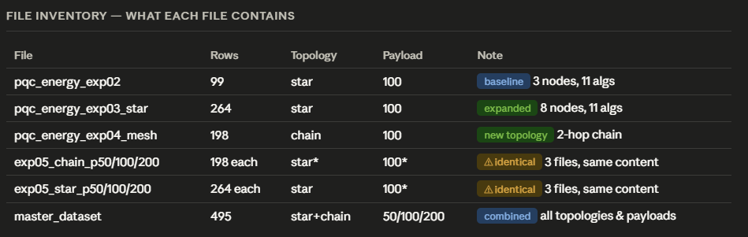

⚠ Data quality issues found: (1) All 6 exp05 payload-variant files contain identical energy data — payload_bytes column is not wired into the simulation energy model yet. (2) exp04 is labelled "mesh" but records topology="chain". (3) Payload and topology have zero effect on energy_mj in the current data.

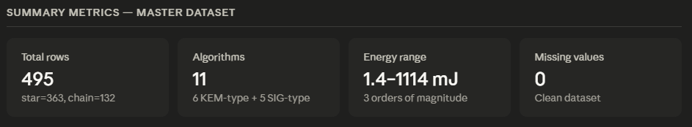

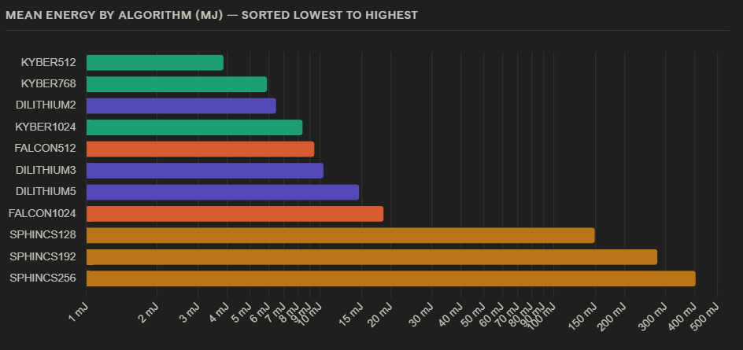

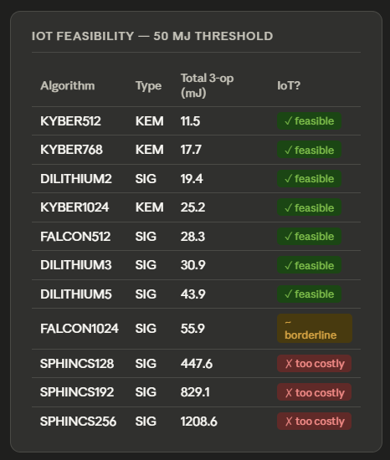

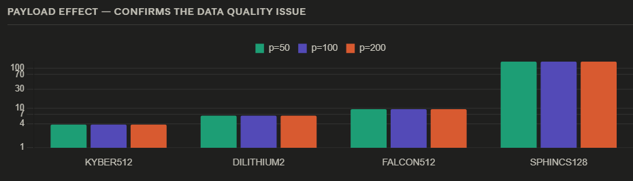

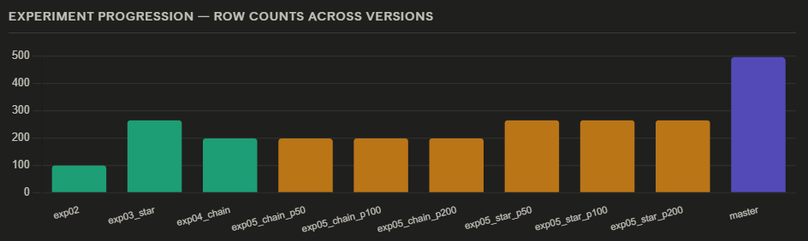

What each file means and where it came from
pqc_energy_exp02.csv — your very first Cooja simulation run. 99 rows, 3 nodes, star topology, payload=100. All 11 algorithms × 3 operations, but only a small number of nodes. This is the baseline you started with.
pqc_energy_exp03_star_topology.csv — you re-ran the same experiment but with more nodes (2 → 8 nodes), producing 264 rows. Same star topology and payload. This was the "scale up nodes" step.
pqc_energy_exp04_mesh_topology.csv — you intended to test mesh topology, but the file actually records topology=chain with hop_count=2. The filename says "mesh" but the data is chain. The 198 rows represent 6 chain nodes.
exp05_chain_p50 / p100 / p200 — the three files intended to test payload sizes (50, 100, 200 bytes) on chain topology. Critical issue: all three files are byte-for-byte identical (same content hash). The payload_bytes column differs in the master, but the energy values are the same — the Cooja simulation wasn't yet updated to account for payload size.
exp05_star_p50 / p100 / p200 — same problem. Three files, all identical in content. Star topology, but payload variation was not simulated.
master_dataset.csv — your combined 495-row dataset pulling all experiments together. It correctly shows star+chain topologies and p=50/100/200 in the columns, but since the underlying exp05 files were identical, energy is the same across all three payload sizes.

Three things to fix before paper submission
- Payload effect is missing — the simulation needs to incorporate message payload into the energy model. Currently payload_bytes = 50, 100, or 200 all give exactly the same energy. This is the most important gap.
- exp04 is mislabelled — the file is called "mesh" but records topology=chain. Either rename the file or re-run a real mesh (multi-hop) simulation.
- exp05 files are duplicates — you have 6 files for payload × topology experiments but only 2 unique datasets inside them. The Cooja script that generated them likely didn't vary the payload parameter between runs.

